AUCTION

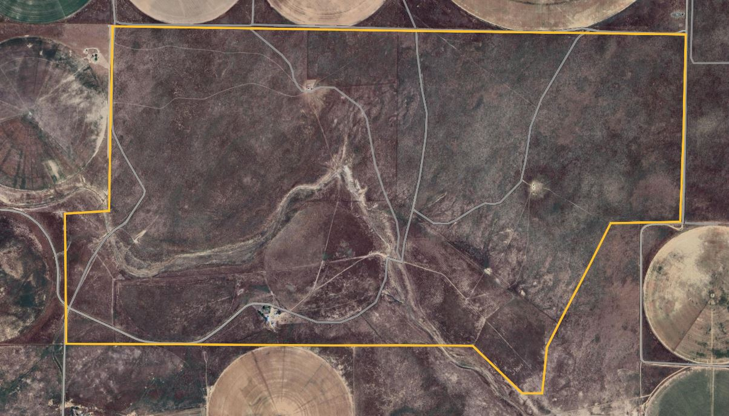

3BR, 2BA, 1359±SF home with 1361±AC Grassland, 15yrs since last farmed.

 Equipment sheds, grain bins, Storage sheds, attached garage.

**Auction to be held off-site @ Holiday Inn Express in Dalhart, TX **

4:30PM Thursday, August 1st

*Call Ryan Rickles to schedule viewing 806-584-8954*

363 Dixon Ln, Texline, TX

**Opening Bid: $100,000**

AssiterRealEstate.com I 806.655.3900

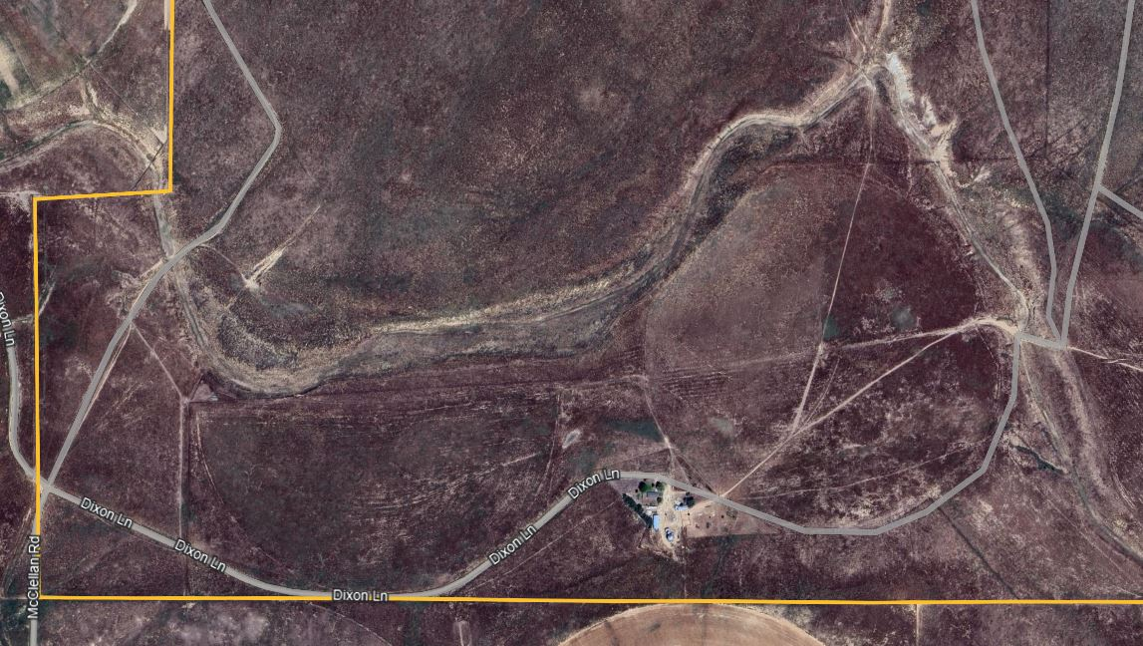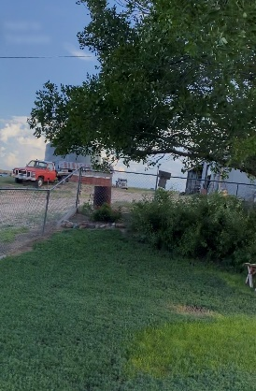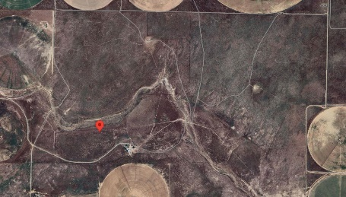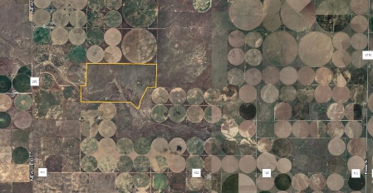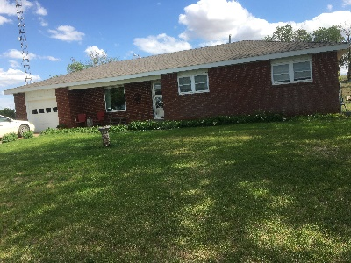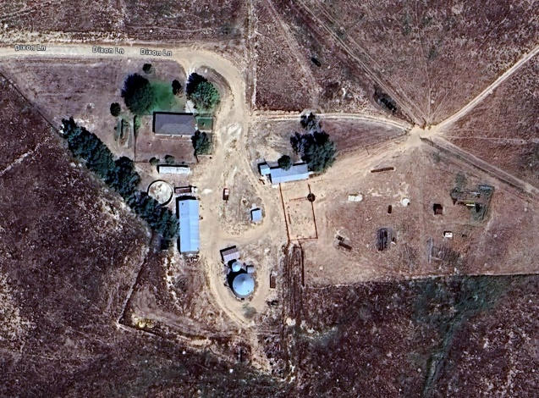±

Auction: 4:30PM Thursday, Aug 1st

Auction Location: OFF-Site @ Holiday Inn Express in Dalhart, TX & Online bidding

21st, 28th, and Feb. 4th

363 Dixon Ln, Texline, TX

Opening Bid: $100,000

A 10% Buyer's premium will be added to the high bid to calculate the purchase price. Buyer must make a 10% down payment immediately following the auction - personal and business checks, cashier’s checks, money orders and cash are accepted with balance due at closing. Title insurance is available at buyer's expense and the real estate taxes will be prorated through the date of closing. The property is being sold "AS-IS" and is not contingent upon buyer financing, property condition or appraisal. Assiter Auctioneers, Ryan & Lindsey Rickles and or Lila Monden are acting exclusively for the seller. T. Assiter, TX License # 6104, RE License # 334107.

Details:

Square Footage: 1359±

Bedrooms: 3

Baths: 2

Lot Size: 1361±AC 

Closing: On or before October 1st, 2024

*See our website for full details!*

Contact:

Ryan Rickles 806.584.8954

Lindsey Rickles 806.584.3336

Contact:

Ryan Rickles-806.584.8954

Lindsey Rickles-805.584.3336

Terms on Real Estate

AssiterRealEstate.com I 806.655.3900